
a
Company
Logotype

Cone Beam Computed Tomography- Report



Porur Dental X-rays & CBCT

Patient Name : Mr. Krishnamoorthi | Date of Report : 12.06.2025
Age/ Gender : 73 years/ Male | Region of Interest : CBCT Maxilla
Referring doctor: Dr. Selva Ganesh | Indication : Implant assessment
Clinical Notes: Nil
PATIENT INFORMATION

CBCT- Maxilla provided
CBCT – IMAGE DETAILS

RADIOGRAPHIC INTERPRETATION

- Completely missing crown and root portion in relation to 16, 17, 26, 27.
- Root stumps: 18
- The maxillary alveolar ridge is present with normal trabecular pattern.
- In relation to 14, 24 presence of hyperdense restorative material involving the crown and extending into the pulp canal upto the apical third of the roots is evident.

IMPLANT ASSESSMENT

 | 15 region | 16 region | 17 region | 25 region | 26 region | 27 region
Sub-Crestal | 6.87 | 8.51 | 9.91 | 7.55 | 6.73 | 6.73
Mid- Crestal | 6.99 | - | - | 7.02 | - | -
Distance between the alveolar ridge and Floor of the Nasal cavity (in mm) | 2.9 | 2.8 | 4.44 | 3.8 | 3.18 | 2.92

RADIOGRAPHIC IMPRESSION

- Partially edentulous maxillary arch.
- Root stumps: 18.
- Root canal treated teeth : 14, 24.

Kindly correlate with clinical findings


IMAGES FOR REFERENCE

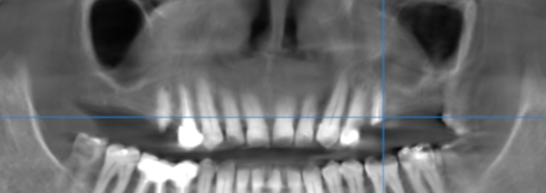

3-DIMENSIONAL VIEW

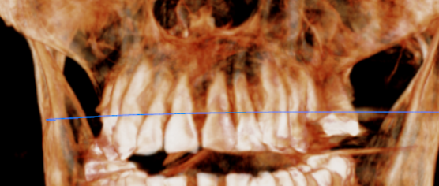

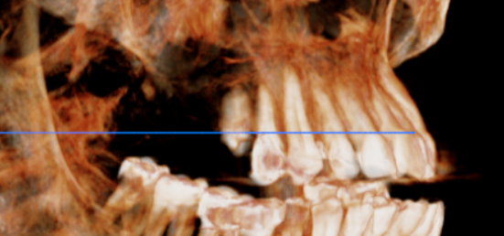
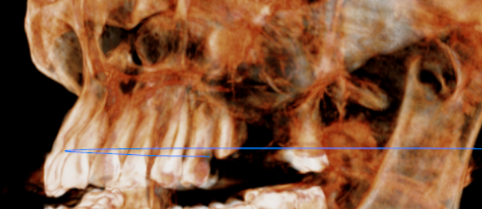

CROSS SECTIONAL VIEW

15 region | 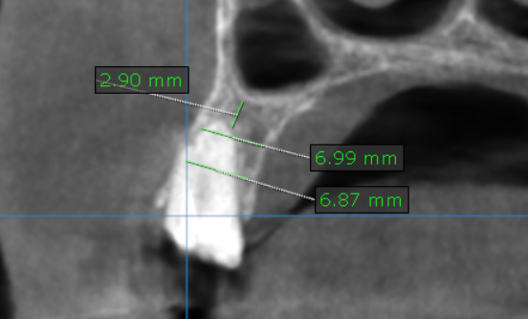
16 region | 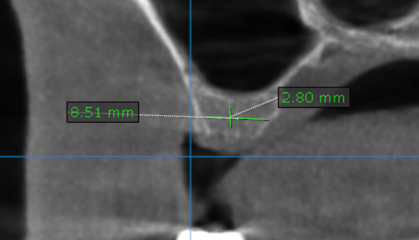
17 region | 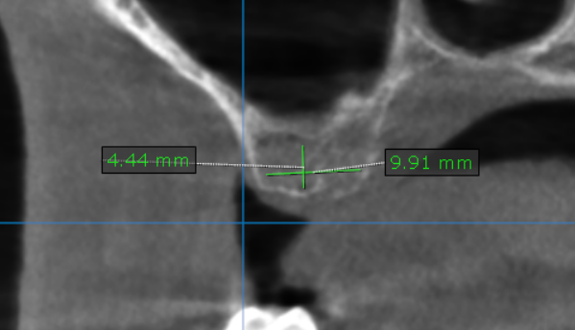
25 region | 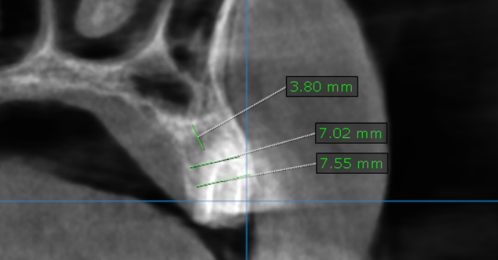
26 region | 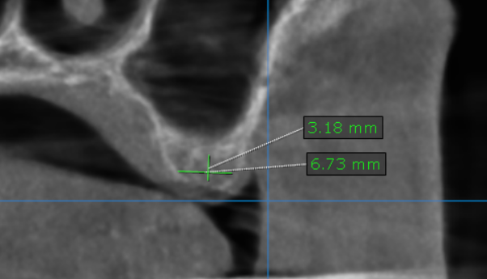
27 region | 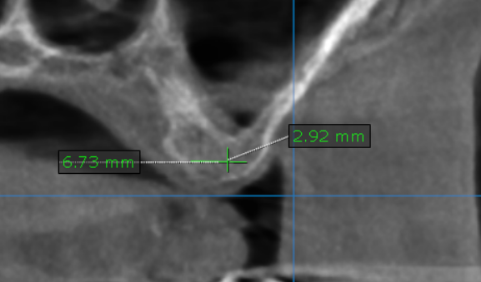

**** End of report ****

